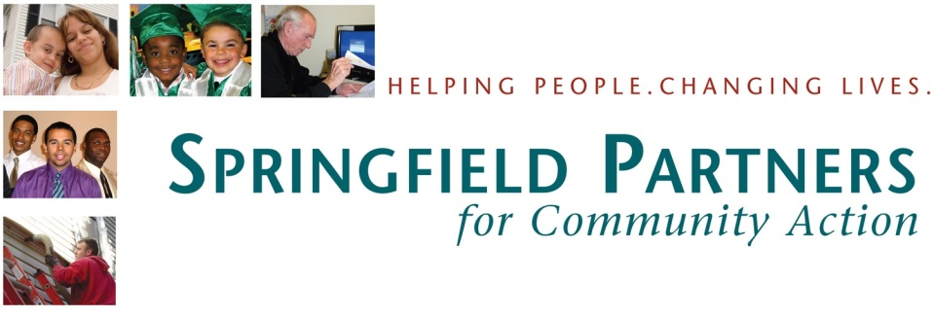

Are you currently receiving HomeBASE Rental Assistance?
Are you prepared for what will happen after it ends?
Want us to help you figure it out?
Tell your HomeBASE case worker to refer you to the
Springfield Partners for Community Action Self-Sufficiency Program!

To be eligible:
- Must be currently on HomeBASE Rental Assistance
- Coming off rental assistance any time after 10/31/13
- Receiving TAFDC/TANF Benefits

Contact: Katasha Leggett
HomeBASE Program Coordinator
(413)263-6500 ext. 6564
Katashal@springfieldpartnersinc.com

