Western MA Subcommittee on XXXXXXX
Quarterly Status Report
Report Selection Criteria
From Date: As of Date:
To Date: Project Type(s):
Project Type(s): Ran By:
Data Not Included:
Additional Data Filters Applied:
Returns to Homelessness - Results from This Quarter
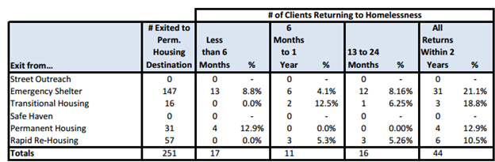

Returns to Homelessness - Results from Last Quarter
Key Findings
_______________________________________________________________________________________________________________________________________________________________________________________________________________________________________________________________
Length of Time Persons Remain Homeless - Results from This Quarter
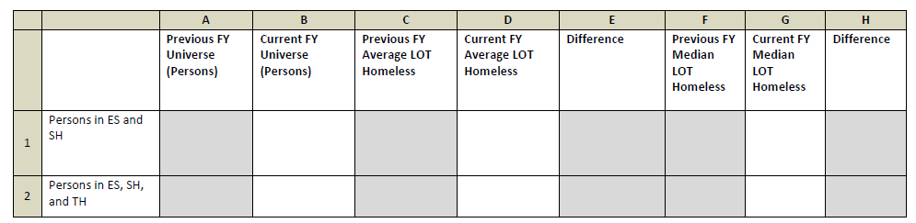
Length of Time Persons Remain Homeless - Results from Last Quarter
Key Findings
_______________________________________________________________________________________________________________________________________________________________________________________________________________________________________________________________
Discussion Points
Which key strategies seem to be making the most impact?
_______________________________________________________________________________________________________________________________________________________________________________________________________________________________________________________________
What action items do we want to accomplish before the next meeting? _______________________________________________________________________________________________________________________________________________________________________________________________________________________________________________________________
Based on these results are we on pace to meet the goals established by this subcommittee? Yes / No
Do we need to consider revising our goals at this time? Yes / No
Other Notes / Comments _______________________________________________________________________________________________________________________________________________________________________________________________________________________________________________________________

