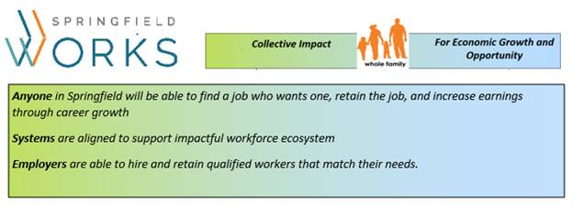 | “Whole Family” Collaborative Outreach System for Training and Work

Goal: Anyone in Springfield will be able to find a job who wants one, retain the job, and increase earnings through career growth

Instructions: This questionnaire is a tool to help case managers, family engagement coordinators, mentors, and others identify clients who may be ready, willing, and able to take full advantage of training to enter the workforce.
Note that the questions below do not necessarily exclude a client from participating in a training, but can help impact the success of a participant. Please assess the overall preparedness of each client based on the tiers below. Once you have identified who is ready for training and work, training providers and employers will visit your site to present training programs and employment opportunities. Partners in the Springfield WORKS/Western Mass WORKS network will help to coordinate this and to help mitigate services to ensure client success.
How do you know if the client is ready?
- Does the client have a high school diploma or equivalent?
- Can the client legally work in the USA?
- Is the client fluent in English?
- Will domestic violence, mental health, housing, substance abuse or DCF issues be a barrier to full attendance and participation in a training?
- Does the client have a clean CORI? (some trainings will enroll individuals with a CORI record)

How do you know if the client is willing?
- Does the client have the drive to change his or her life for the better?
- Is financial self-sufficiency a goal?
- Can the client commit to training and does the client have a desire to work?

Is the client able?
- Does the client have access to reliable transportation and/or a nearby bus stop?
- Does the client need assistance securing childcare in order to work?
If employment is a major goal, please check all that apply to determine whether your client is ready, willing, and able to work? | Please check all that apply.  YES NO
Tier 1: “Ready” for work readiness and skills training for a career pathway
Has HS Equivalent or Higher or active in ABE and referred to training by a case manager
Is Legal to Work
Is an English Speaker with Comprehension
Is committed to training and setting outcome goals for employability or skills training
Needs Child Care Plan (has some childcare but needs a plan to support training and work hours)
Has access to a car or public transportation
CORI (some trainings will enroll individuals with a CORI record)
Disability
Cliff Effect
Long Term Unemployment
Needs Coach/Case Manager
Tier 2: “Getting Ready” for Training / Work :
Resident is unsure whether to set employment goals
Lacks essential soft skill competencies
Making Progress on Mental Health
Resolving Immigration Status
Substance Abuse
Experiencing Domestic Violence
Has an open DCF case
Needs Stable Housing
Has no Child Care Support (No childcare or family support)
Has no Access to a Car or Reliable Transportation
Tier 3: “Residents Without a High School Equivalent”
HS Equivalent is a Goal
HS Equivalent is not a goal, but Education Gains are a Goal

