Have you been financially affected by COVID-19?
You may be eligible for assistance!!

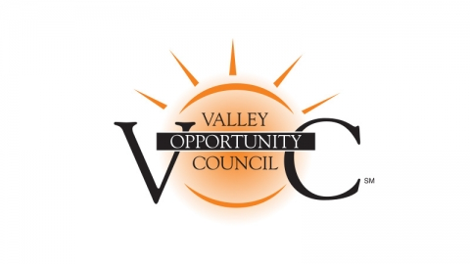
Lost your job, had your hours reduced or just having trouble making ends meet?? Let us help!!

We can assist with things like:
- Past due Rent
- Overdue Mortgage
- Food and more
VOC is a nonprofit community action agency with programs to assist during this unsettling time. We believe in supporting families and friends from our community to achieve greater independence and a higher quality of life.

Want to learn more? We are here to help!!!

Contact us at 413-534-2466 Ext 550

FBenton@valleyopp.com

VOC Programs

Fuel Assistance, Heating System Repair, Early Education & School Age Programs, Food and Nutrition Services (WIC, The Chicopee Farmers Market), Adult Programs (Adult Basic Education, Citizenship Classes, Senior Companion Program) Housing (Veteran’s Housing, Homeless/Supportive Services, Volunteer Tax Assistance) and more

