
May 9, 2023

Senator James Eldridge and Representative Michael Day
Joint Committee on the Judiciary
24 Beacon Street, Room 136
Boston, MA 02133

Re: Testimony in Support of Access to Counsel, Eviction Protections, Eviction Record Sealing and more

Dear Senator Eldridge and Representative Day:

I am pleased to submit this written testimony on behalf of the Western Massachusetts Network to End Homelessness in support of key legislative priorities outlined below.

The Western Massachusetts Network to End Homelessness supports collaborative solutions across Hampden, Hampshire, Franklin and Berkshire Counties to prevent and end homelessness through a Housing First approach that centers racial equity. It includes hundreds of partners from virtually every community sector who are committed to making safe, decent and affordable housing a reality for all in western Massachusetts.

Towards that end, the Network urges the Judiciary Committee to act as quickly as possible to advance the following bills:

H.1731 – An act promoting access to counsel and housing stability in Massachusetts (Representative Rogers and Representative Day)

Right now in western Massachusetts and across the Commonwealth, the overwhelming majority of families are suffering the trauma of eviction every day without legal representation. Over 85% of landlords have legal counsel while over 89% of tenants face eviction proceedings without it. This imbalance turns an intended justice system into an engine of injustice.

In Western Massachusetts Housing Court in the first quarter of 2023 alone, 1,900 evictions have already been filed against tenants. At the same time, over 2,000 families were counted as homeless in western Massachusetts Point in Time count in January, 2023, higher than any point in the last 5 years. Additionally, Blacks made up 23% of the homeless population while only comprising 5% of the general population, 4.6 times higher than their representation of their population. Access to counsel is a critical step towards addressing the gross racial inequity in homelessness.

H.1682/S.1048 - An Act relative to summary process and rental assistance to make permanent and improve Chapter 257 protections and the 2-tier eviction process (Senator Miranda and Representative Montaño)

In the month of April, 2023 alone, close to 2,500 western Massachusetts households sought rental assistance to preserve their tenancies. The application approval process requires three to six weeks. During this time, the threat of eviction and homelessness looms large for these families. This bill will ensure the common-sense continuance of an eviction process while a rental application process is pending. In the name of equity, housing stability and preventing more homelessness across the Commonwealth, Chapter 257 protections must be made permanent.

H.1690/S.956 - An Act promoting housing opportunity and mobility through eviction sealing (HOMES) (Senator Edwards, Representative Moran)

The Network regularly convenes housing navigators across the region who are working to help people exit homelessness into permanent housing. While the lack of affordable housing is the first barrier named, the very close second is this: the fact of an eviction record – no matter the reason or how long ago – frequently creates an insurmountable barrier to finding a place to live. I am honored to bring their voices, and the voices of the people they serve, to this urgent need to pass the HOMES Act.

While this bill will help many tenants and we appreciate the work of its lead sponsors, I want to urge the Committee to clarify that if a tenant’s case is dismissed or if there is a judgment in their favor that their record will be sealed. Additionally, on behalf of our Network partners, I ask the Committee to consider amendments to the bill so that tenants do not have to exclusively bear the burden to petition the court to seal their eviction record. Similar to the case made for Access to Counsel, the overwhelming majority of tenants with an eviction record will not be aware of their right to petition, much less after four seven years. Requiring tenants to petition for sealing in all cases undermines the very goal this bill seeks to accomplish, and we appreciate your reconsideration of this provision.

Additionally, the Network asks the Committee to support the following bills:
- H.1530/S.999 - An Act Relative to Vacant Receivership Property, Representative Gonzalez, Senator Gomez
- S.994 – An Act preventing unnecessary vacancies in foreclosed homes, Senator Gomez
- S.921 - An Act protecting equity for homeowners facing foreclosure, Senator Comerford

Thank you for issuing a favorable report for these bills. We deeply appreciate your consideration.

Best,
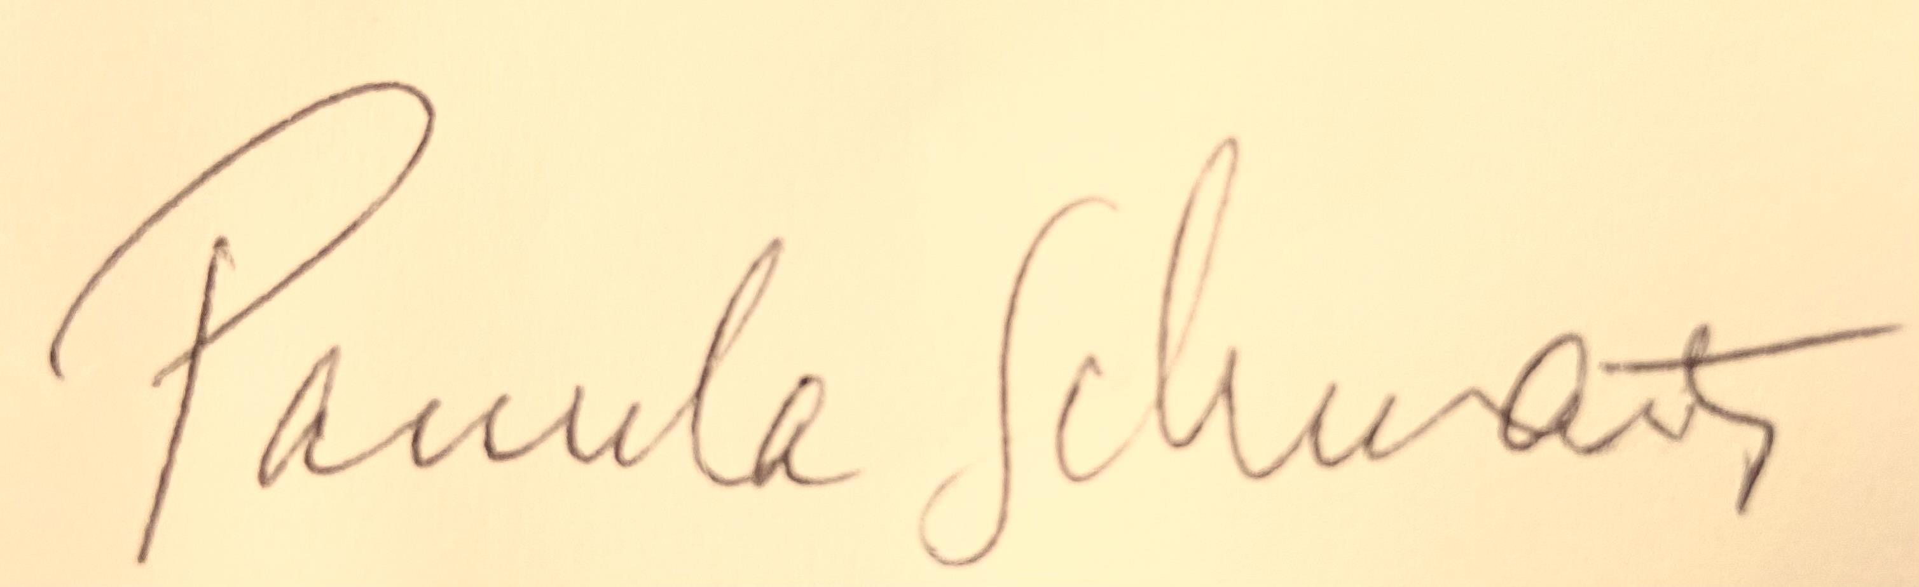
Pamela Schwartz, Director
Western Massachusetts Network to End Homelessness
pschwartz@westernmasshousingfirst.org
413-219-5658
http://westernmasshousingfirst.org

